**PERIYAR UNIVERSITY**

|  |  |
| --- | --- |
| **PROJECT TITLE** | **Analyzing the Housing Prices of Metropolitan cities in India** |

|  |  |
| --- | --- |
| **Team Id: NM2023TMID22595** | |
| **Student Name** | **Student NM Id** |
| THENMOZHI R | C9F52AE44DD0EFA896D4F63D14CAF60D |
| GEETHA N | 88B56DF992710F587F84752C80E5AF3F |
| GOMATHI C | 020E74BA6225472B64545A228C3D0C45 |
| PREMALATHA L | FA97479BDD0F59EA09E4B48047DEC54A |

**INCHARGE: Mr. K. CHINNAIYA, M.Sc., M.Ed., M.Phil.,**

**III-B.Sc., Mathematics (2023-2024)**

**DEPARTMENT OF MATHEMATICS**

**ARIGNAR ANNA GOVERNMENT ARTS COLLEGE, ATTUR**







**1) INTRODUCTION:**

* Purchasing a new house is always a big decision. Moreover, economic growth plays an important role as housing demand is often seen as elastic in terms of income, leading to an increase in revenues for households. House price prediction in a metropolitan city in India is a valuable solution for potential home buyers, real estate agents, and investors. By leveraging historical sales data, property details, and location-specific information, a predictive model can accurately estimate house prices.
* The model's scalability, real-time updates, user-friendly interface, and transparency ensure it meets the needs of stakeholders. Integration capability, data privacy, and cost-effectiveness are also important considerations.
* It rerport contains correlation of housing prices imformation such as
* Area or location
* Prices of Home things like sofa, TV, Washing machine etc.,.
* Intercom, Maintenance staff, Security
* Lattitude
* Longitude
* By addressing these requirements, the prediction model provides reliable insights, empowering stakeholders to make informed decisions in the fast-paced real estate market. In this project, we will develop and evaluate the performance and the predictive power of a model trained and tested on data collected from houses.
* House price prediction can help determine the selling price of a house and can help to arrange the right time to purchase a house. There are various factors that influence the price of a house which include physical conditions, concept and location.
* As an important aspect of human settlement, house prices are strongly associated with economic activities. Understanding the trends in house prices can provide suggestions not only for house buyers but also for researchers and decision makers in real estate market, urban planning and development. For decades, researchers from economy, urban planning, geography, politics and computer science have made great efforts in house price-related topics to understand the impacts of property values in different socioeconomic environments.
* In this work, we build the framework, multiple data sources, including house information, built environment, human mobility patterns, and socioeconomic attributes of neighborhoods, are used to understand the value of urban settlements comprehensively.

**2) Problem Definition and Design Thinking:**

**2.1) Brainstroming:**

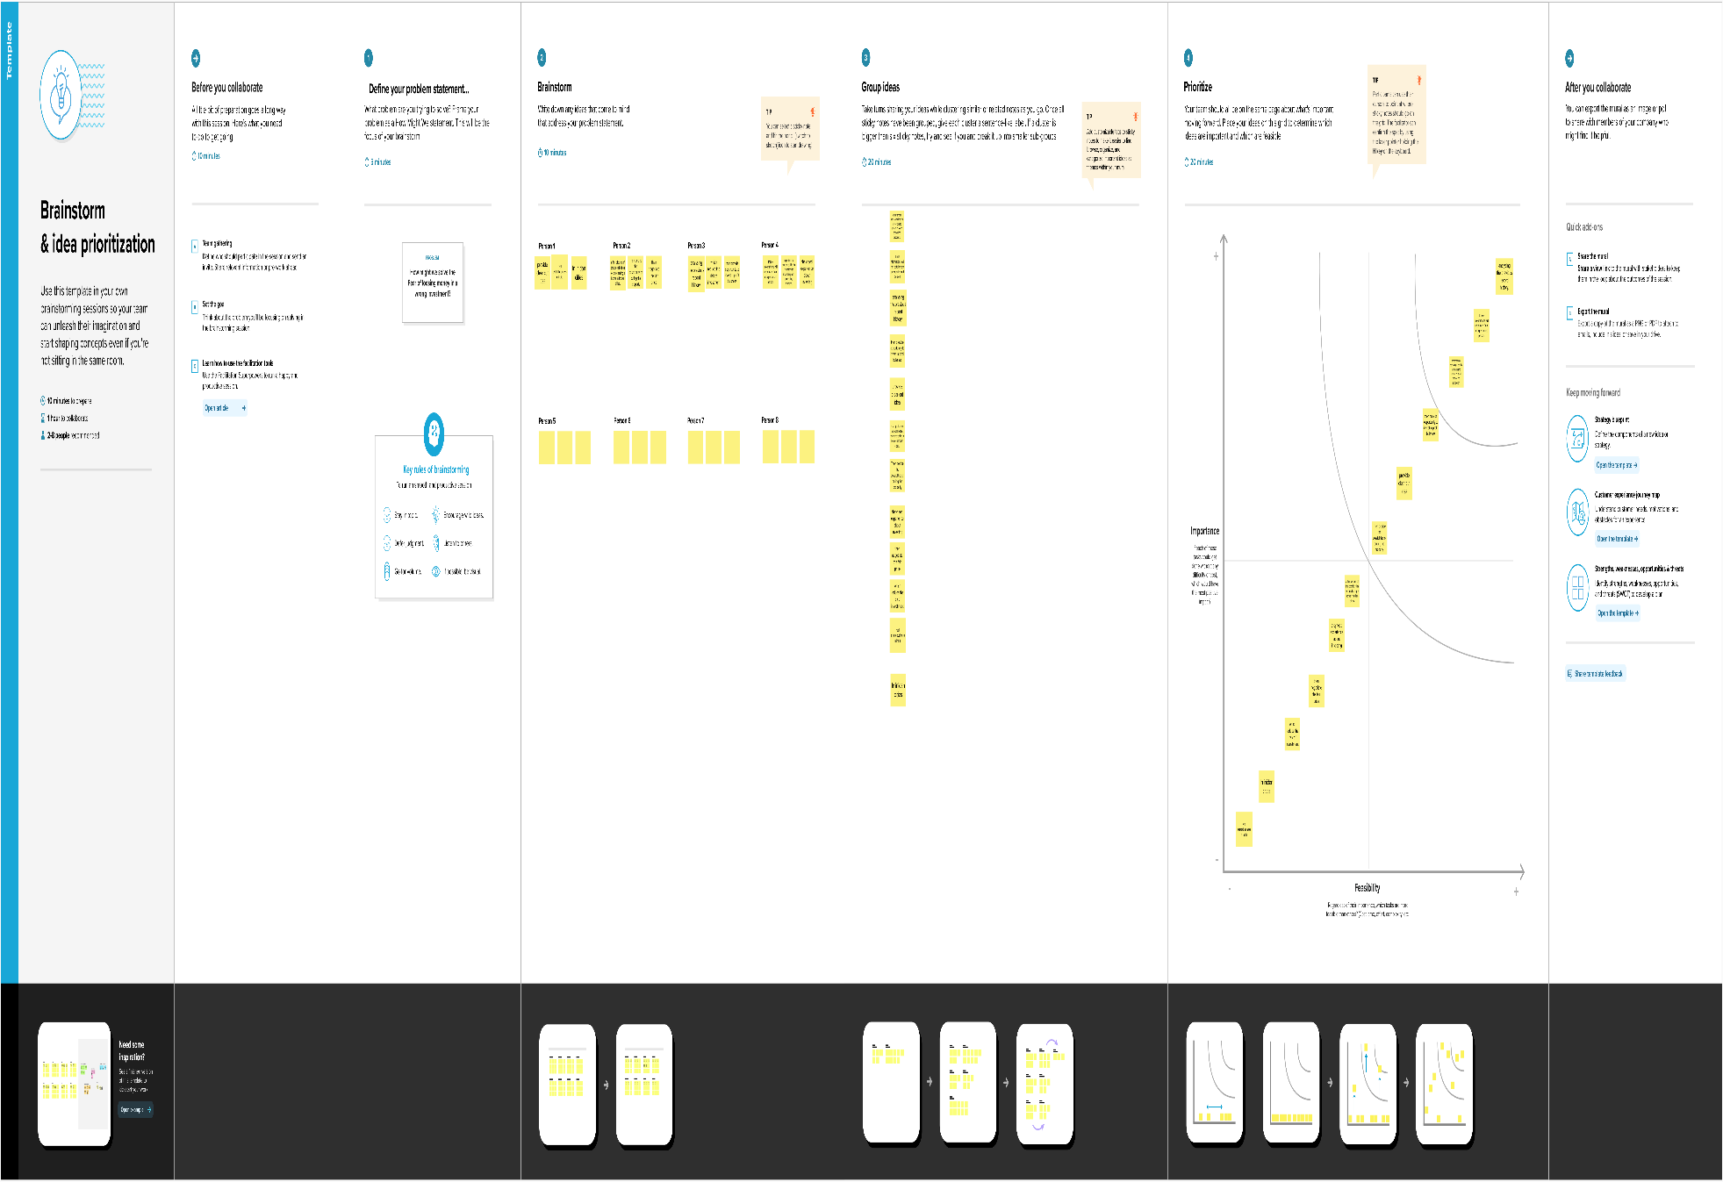

**2.2) Empathy Map**

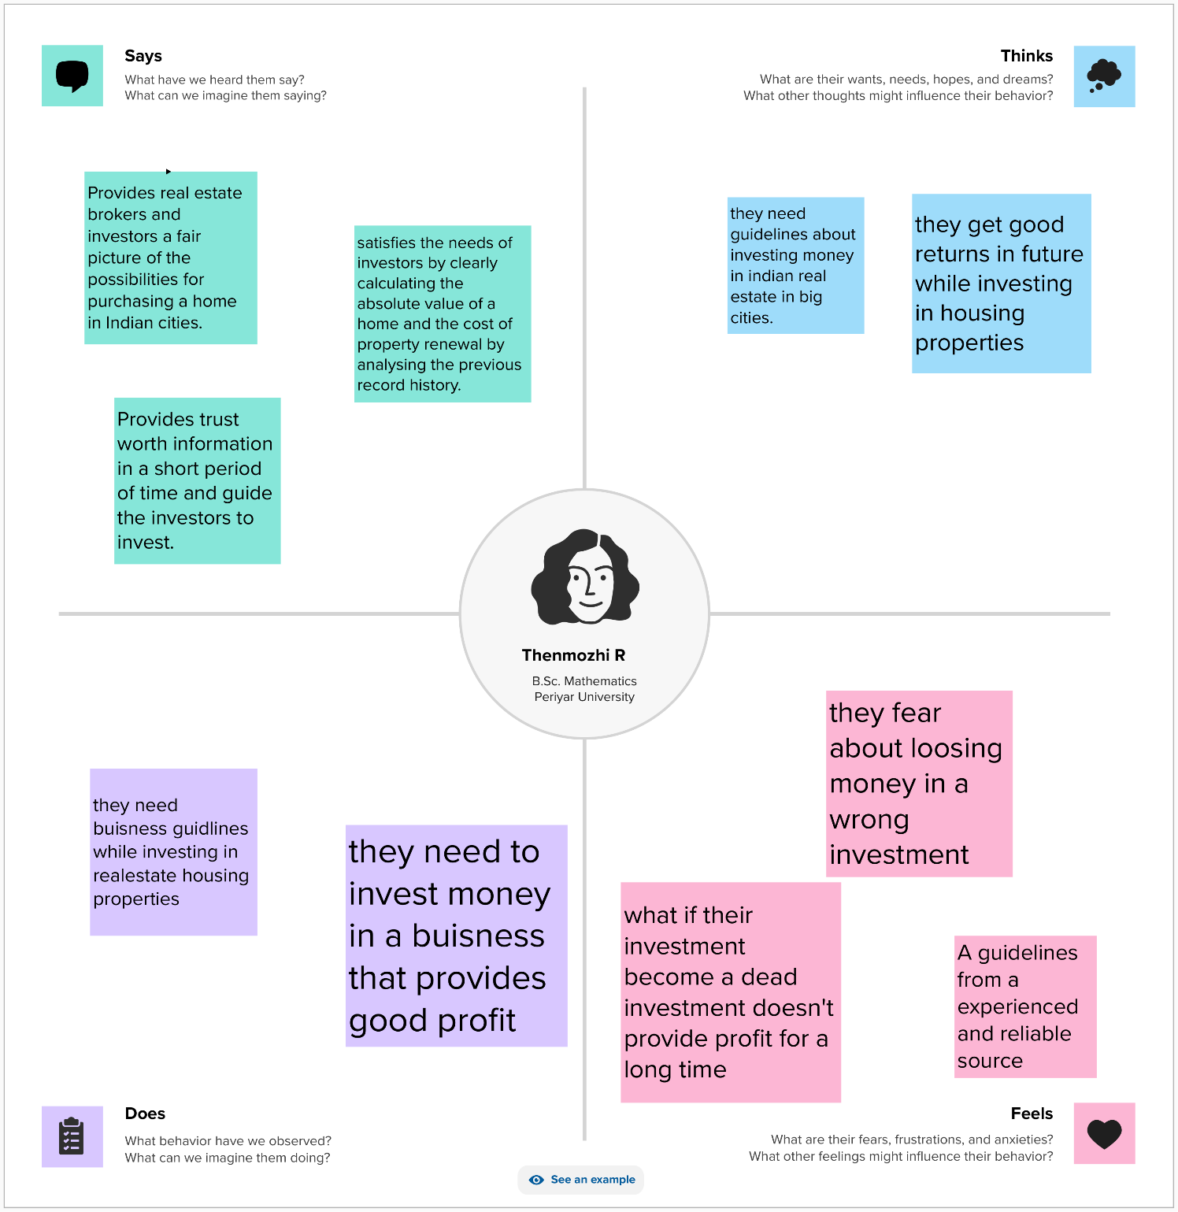

**3) Result:**

**3.1) Dashboard:**

**3.1.1) Dashboard 1:**

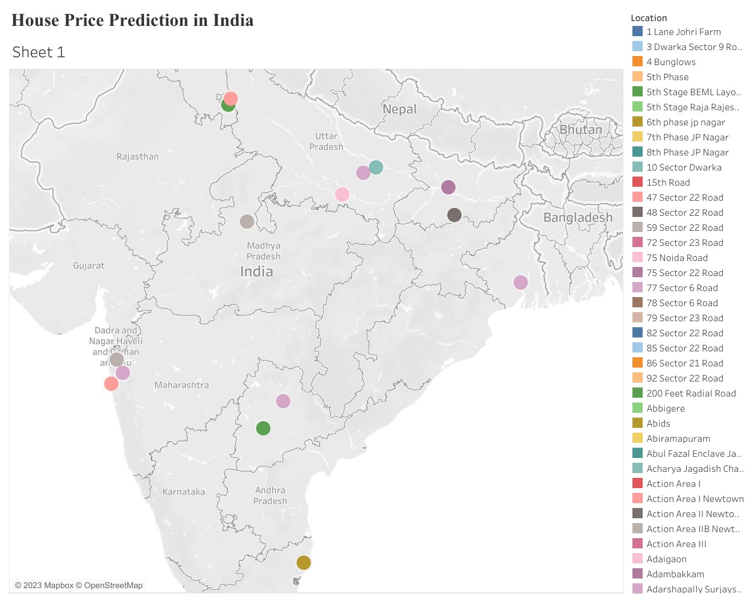

**3.1.2) Dashboard 2:**

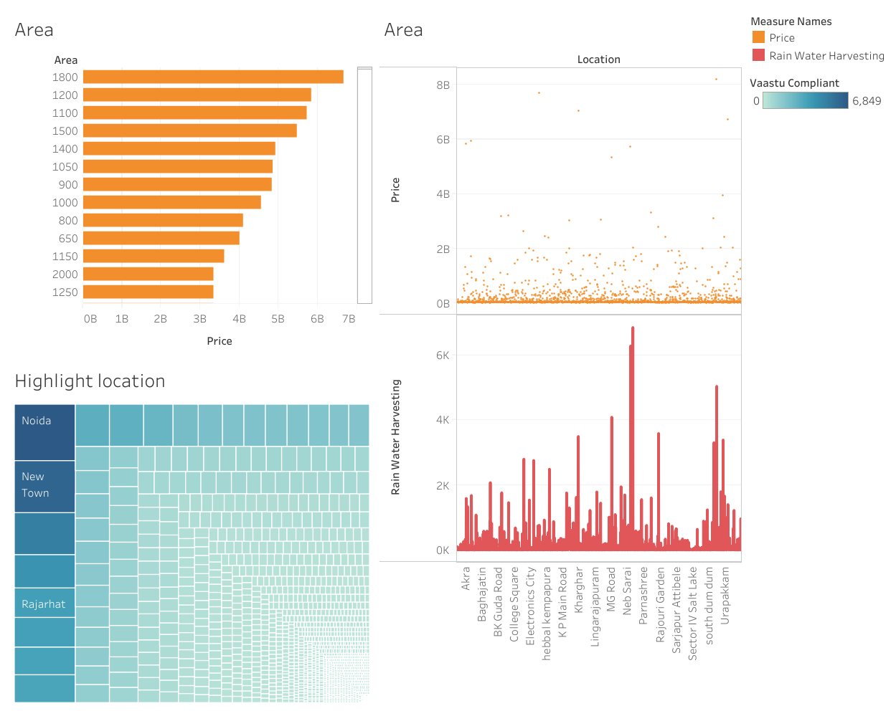

**3.1.3) Dashboard 3:**

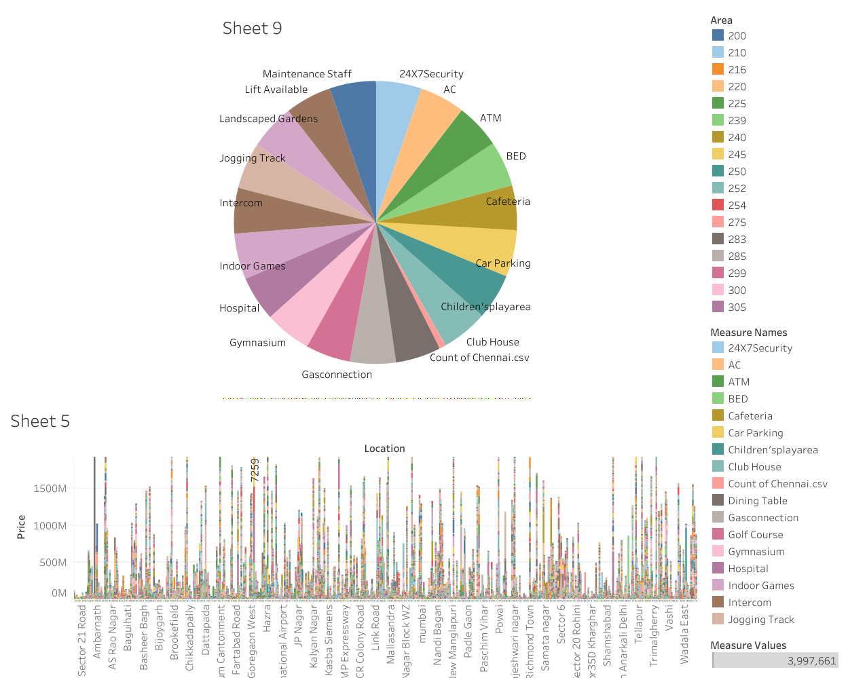

**3.1.4) Dashboard 4:**

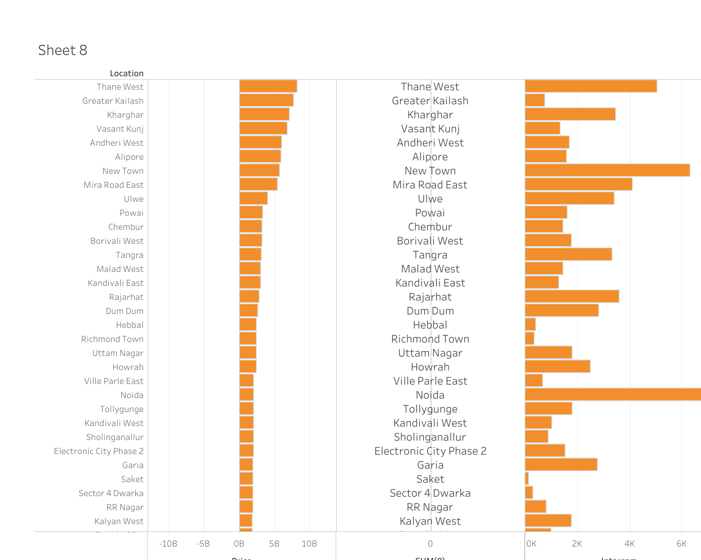

**3.2) Story:**

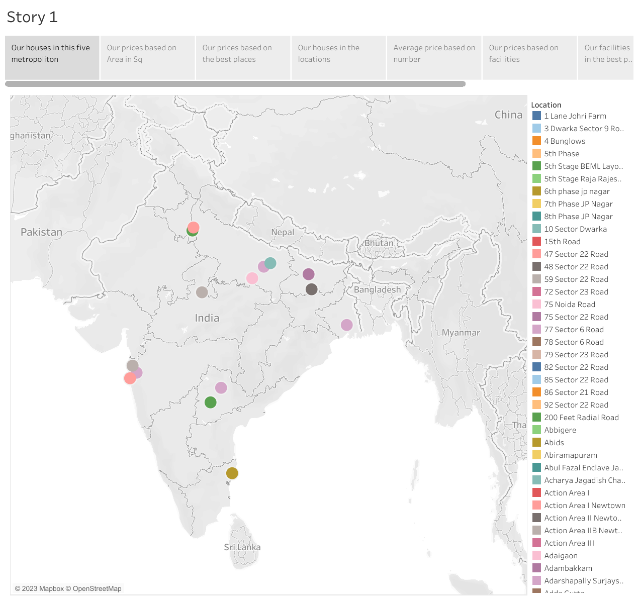

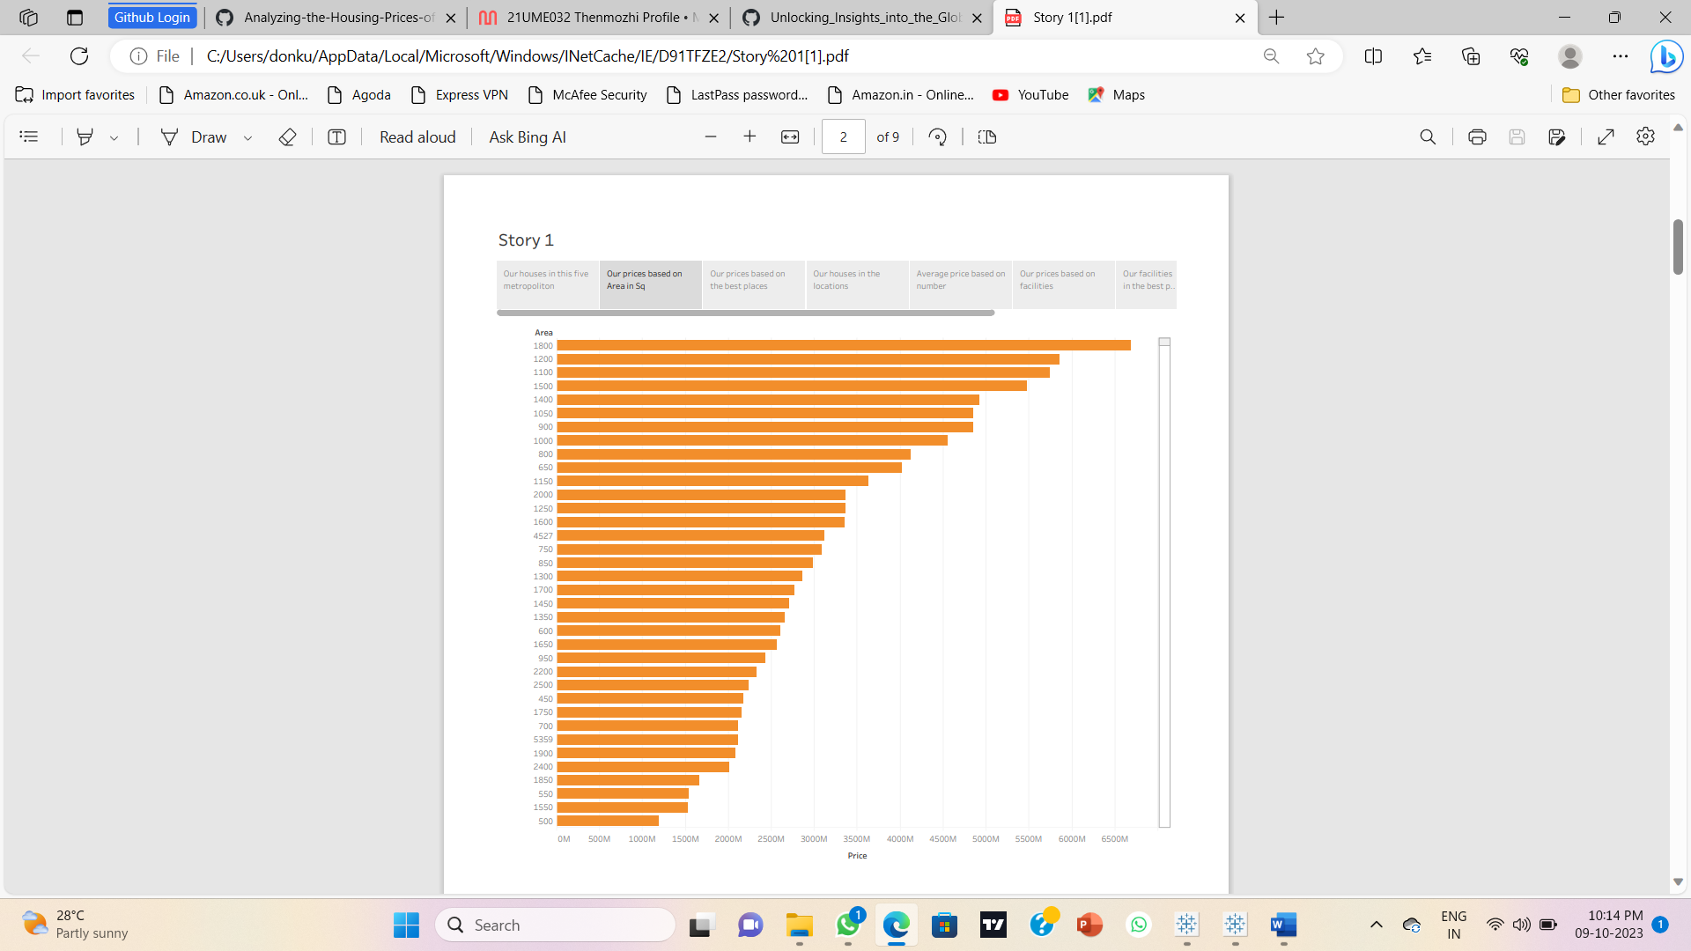

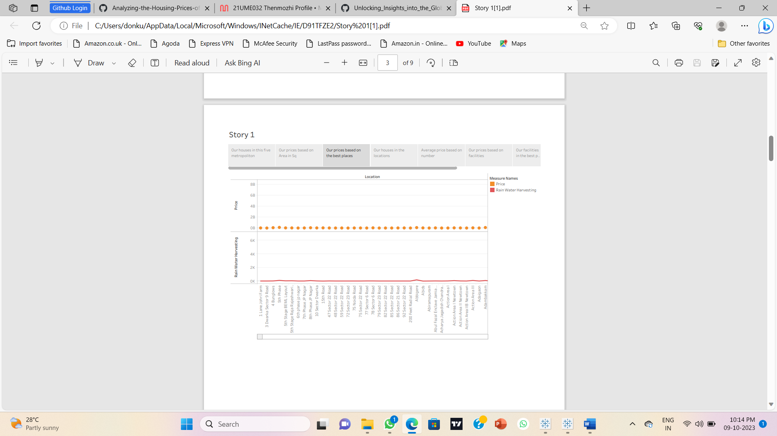

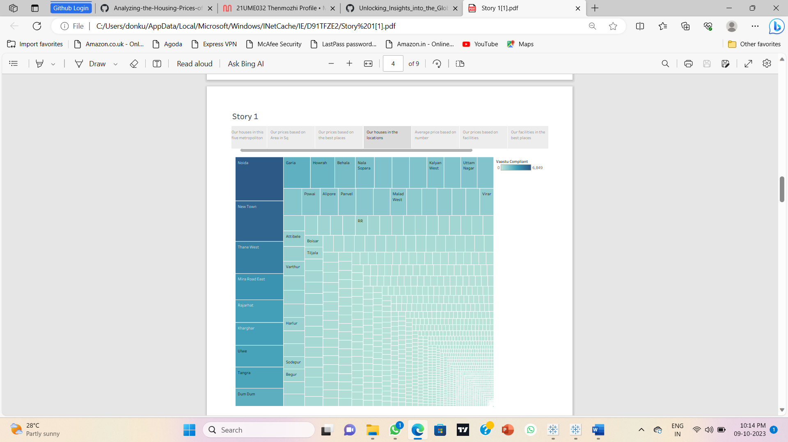

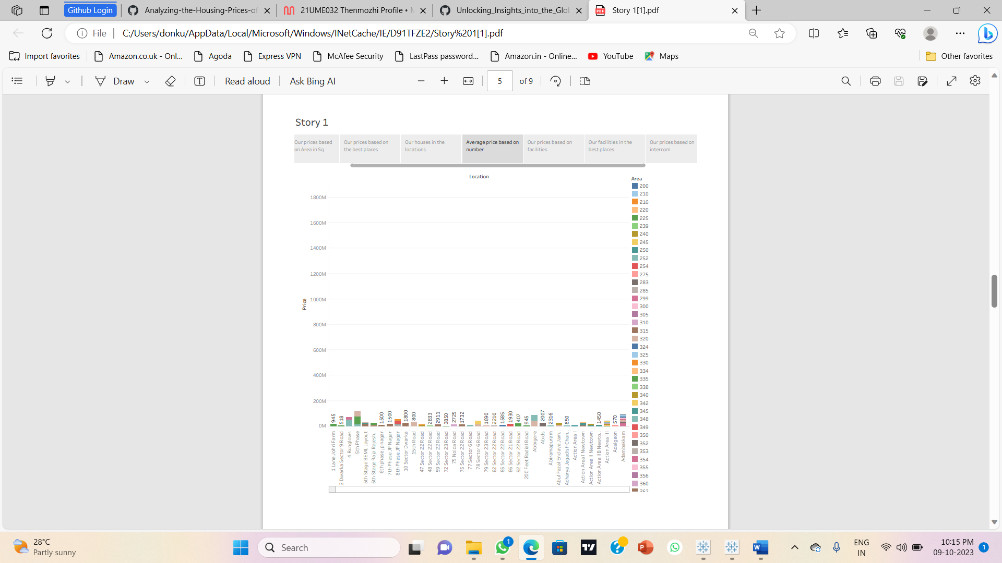

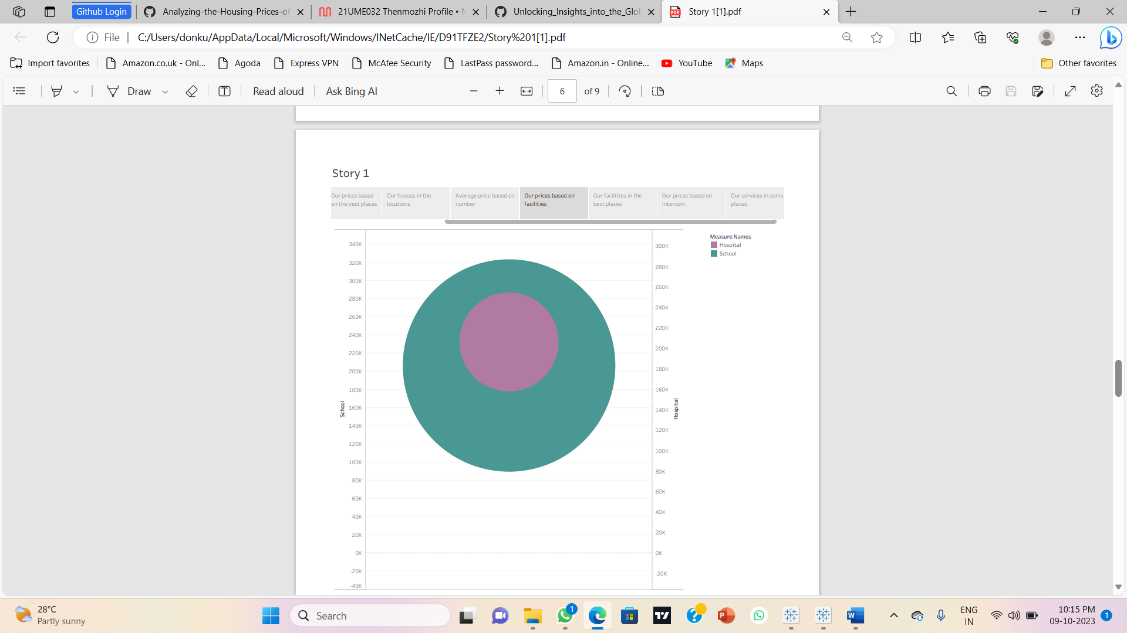

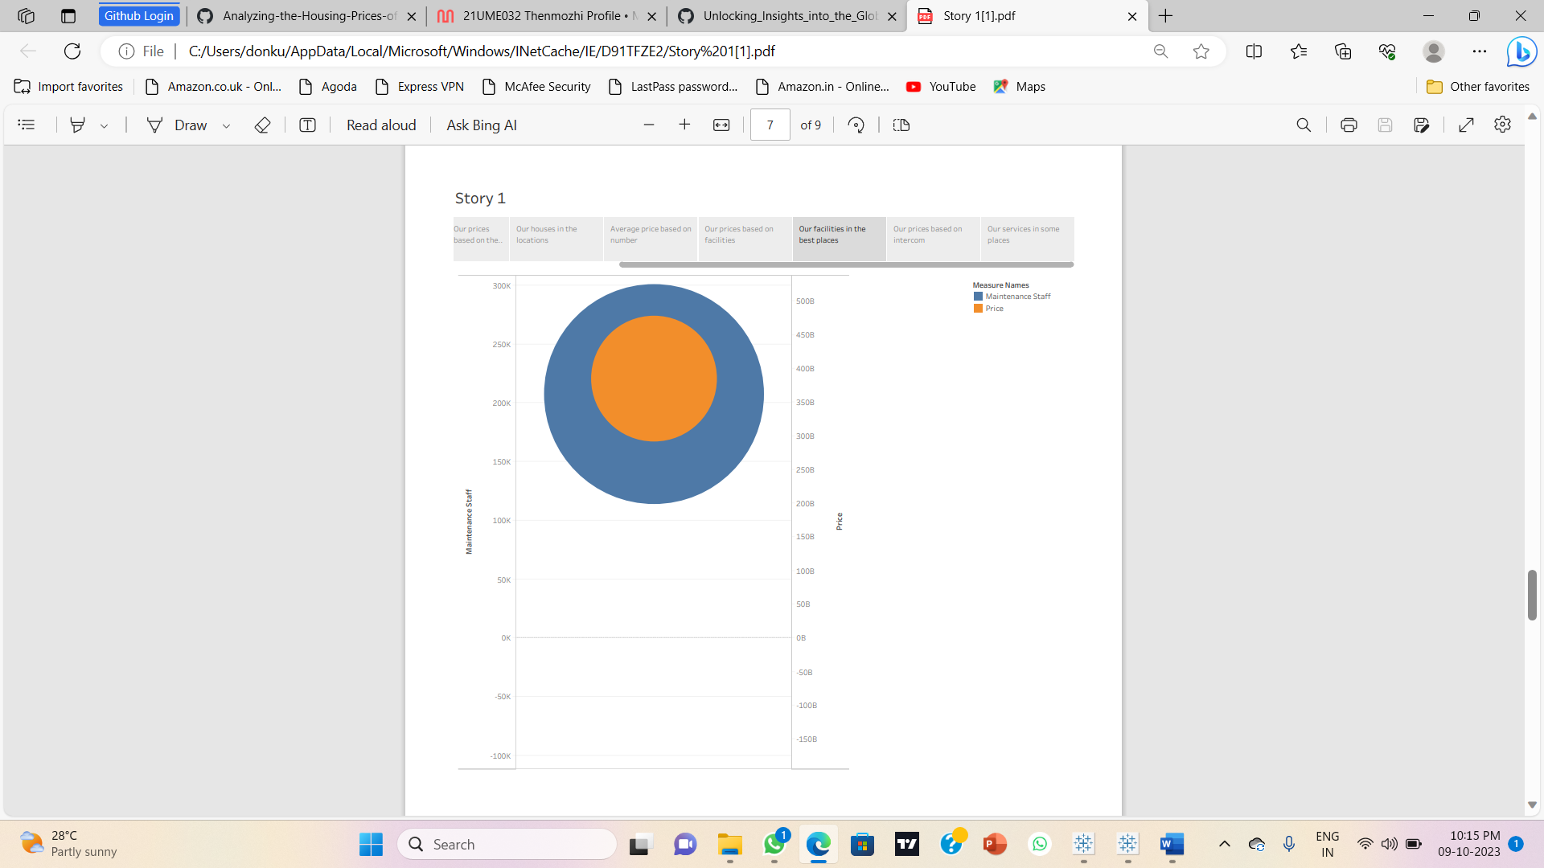

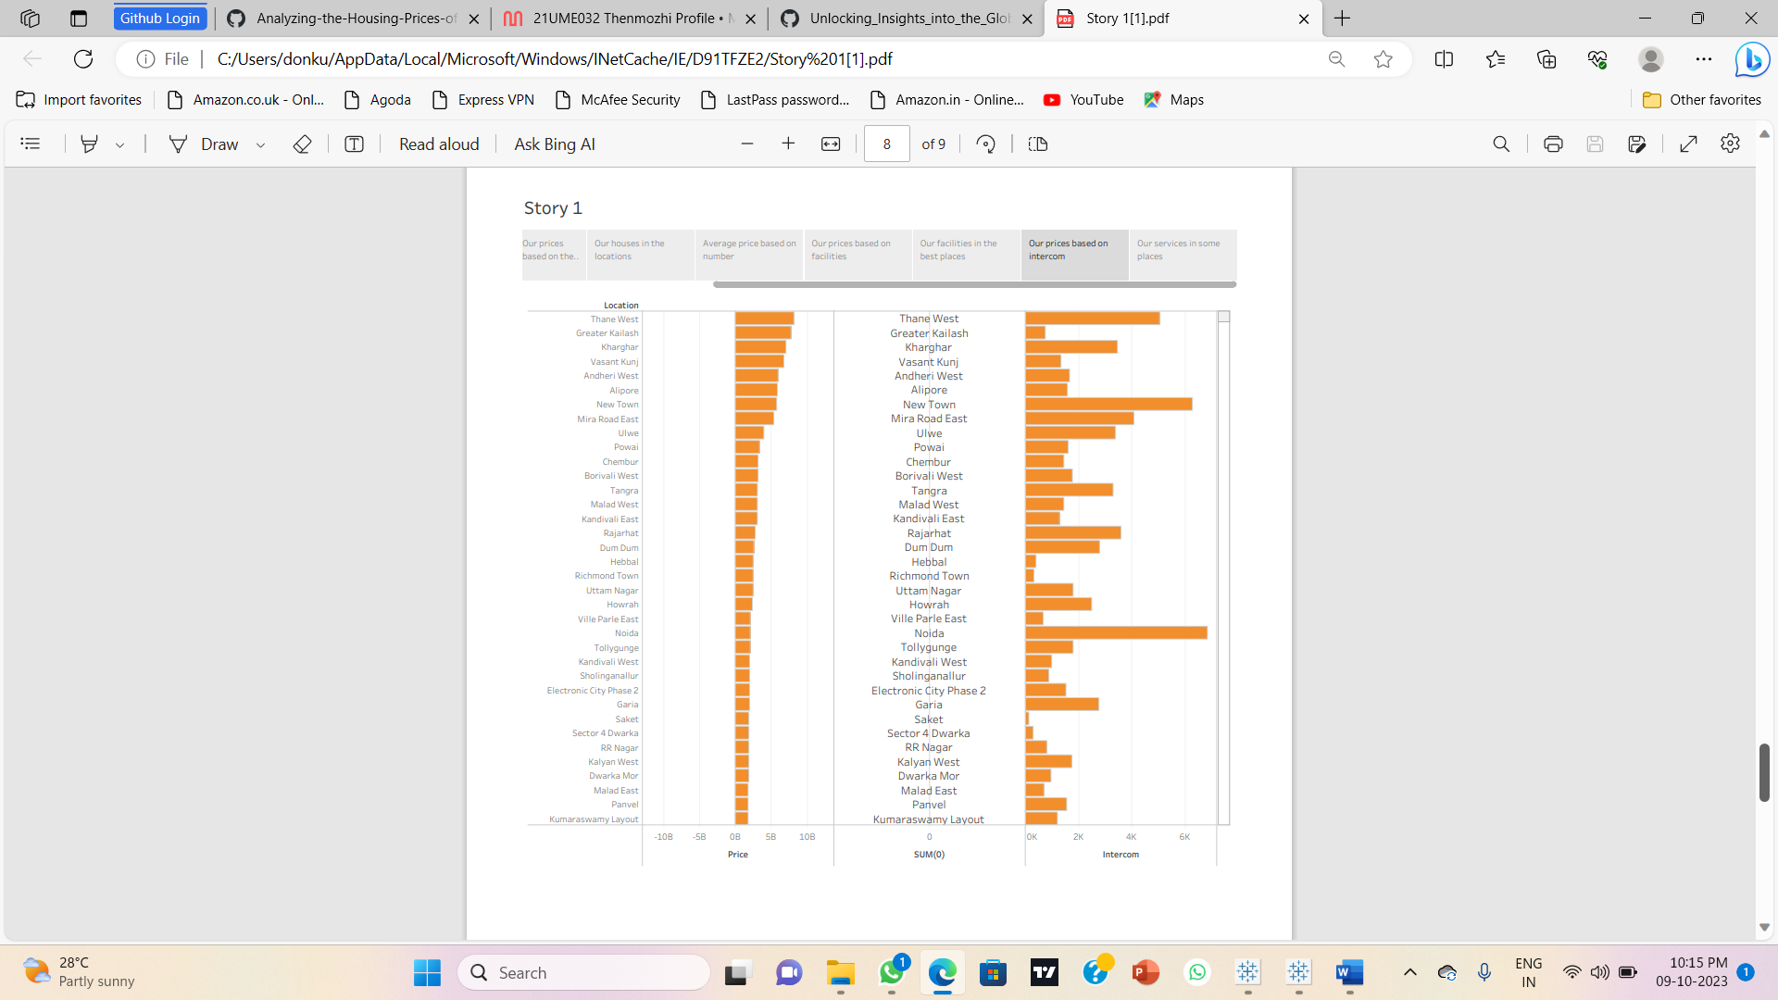

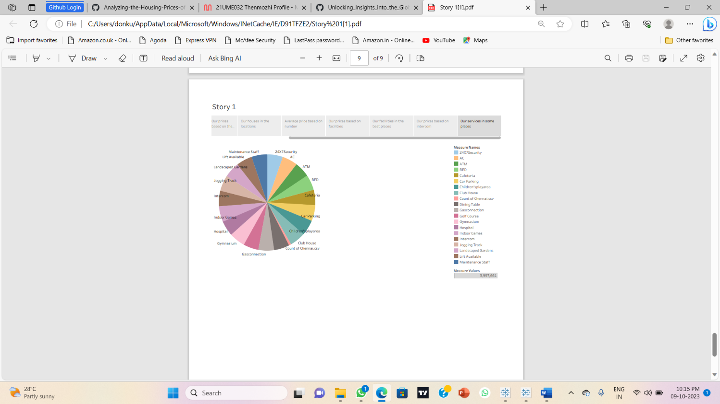

**4) Advantages and Disadvantages:**

**4.1) Advantages of House Price Prediction in India**

* It can help buyers and sellers make informed decisions
* It can help investors make better investment decisions
* Similarly, sellers can use this information to decide when to sell their property for maximum profit
* In addition, house price prediction can help banks and other financial institutions make better lending decisions.
* By predicting the future prices of houses, buyers can decide whether to buy a house now or wait for a better deal
* By predicting the future prices of houses, banks can decide whether to approve a loan or not.

**4.2) Disadvantages of House Price Prediction in India**

* Predictions are not always accurate and should be taken with a grain of salt. [Many factors such as economic conditions, political stability, natural disasters, etc., can affect the housing market and cause fluctuations in prices.](https://www.jetir.org/papers/JETIR2205B24.pdf)
* One of the main disadvantages is that the calculation of house prices is done without the necessary prediction about future market trends and price increase.
* [A poor dataset can negatively affect the predictions](https://www.ijert.org/real-estate-price-prediction)
* Housing market crash occurs when home prices collapse after a time of high prices or a housing bubble. A housing bubble develops when supply outstrips demand, leading to a significant increase in the average price of a home relative to its actual value.
* [If homebuilders continue to build new homes even after demand has begun to decline and sales have slowed, the bubble might burst](https://capital.com/india-house-price-crash-property-sentiment-interest-rates).

**5) Future Enhancement**

* The used pre-processing methods do help in the prediction accuracy. However, experimenting with different combinations of pre-processing methods to achieve better prediction accuracy. Make use of the available features and if they could be combined as binning features has shown that the data got improved.

**6) Conclusion:**

* In future the dataset can be prepared with more features and advanced machine learning techniques can be used for constructing the house price prediction model. In future more real time data can be considered in the website for predicting the house prices and GPS can be added to find housing prices in different locality.
* We present a multi-source-data-fusion framework to estimate the house price appreciation rates from various perspectives by the utilization of several big geo-data sources and the state of the art machine learning approaches.

**Embed code for story:**

<div class='tableauPlaceholder' id='viz1696858432265' style='position: relative'><noscript><a href='#'><img alt='Story 1 ' src='https:&#47;&#47;public.tableau.com&#47;static&#47;images&#47;Bo&#47;Book1_16968958349000&#47;Story1&#47;1_rss.png' style='border: none' /></a></noscript><object class='tableauViz' style='display:none;'><param name='host_url' value='https%3A%2F%2Fpublic.tableau.com%2F' /> <param name='embed_code_version' value='3' /> <param name='site_root' value='' /><param name='name' value='Book1_16968958349000&#47;Story1' /><param name='tabs' value='no' /><param name='toolbar' value='yes' /><param name='static_image' value='https:&#47;&#47;public.tableau.com&#47;static&#47;images&#47;Bo&#47;Book1_16968958349000&#47;Story1&#47;1.png' /> <param name='animate_transition' value='yes' /><param name='display_static_image' value='yes' /><param name='display_spinner' value='yes' /><param name='display_overlay' value='yes' /><param name='display_count' value='yes' /><param name='language' value='en-US' /><param name='filter' value='publish=yes' /></object></div> <script type='text/javascript'> var divElement = document.getElementById('viz1696858432265'); var vizElement = divElement.getElementsByTagName('object')[0]; vizElement.style.width='1016px';vizElement.style.height='991px'; var scriptElement = document.createElement('script'); scriptElement.src = 'https://public.tableau.com/javascripts/api/viz_v1.js'; vizElement.parentNode.insertBefore(scriptElement, vizElement); </script>